MY SQL ASSIGNMENT 4th

**create database company3;**

**use company3;**

create table sales(

SaleID int primary key auto_increment,

ProductID int,

CustomerID int,

SaleDate date,

Quantity int,

UnitPrice int,

Region varchar(15));

insert into sales(SaleID,ProductID,CustomerID,SaleDate,Quantity,UnitPrice,Region)

values(1,101,1001,"2024-01-05",5,200,"North"),

(2,102,1002,"2024-01-10",10,150,"East"),

(3,103,1003,"2024-02-15",2,300,"North"),

(4,104,1001,"2024-02-20",7,250,"West"),

(5,101,1004,"2024-03-05",1,200,"East");

select * from sales:-

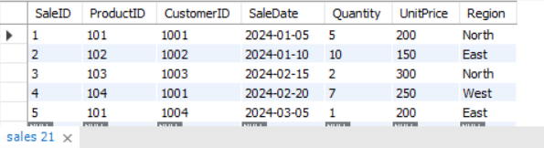

###----1) Write a query to calculate the total sales (Quantity * UnitPrice) for each product.

**select ProductID, SUM(Quantity*UnitPrice) as total_sales from sales group by ProductID;**

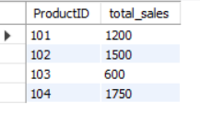

###----2) Write a query to find the total number of products sold in each region.

**select Region, sum(Quantity)as Total_Product from sales group by Region;**

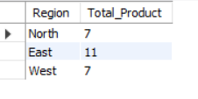

##----3) Writ#e a query to get the average sales amount per product.

**select ProductID, avg(Quantity*UnitPrice) as Average_Sales from sales group by ProductID;**

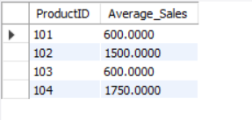

###----4) Find the regions where total sales are more than 3000.

**select Region,sum(Quantity*UnitPrice) as Total_Sales from sales group by Region having sum(Quantity*UnitPrice)>3000;**



###----5) Write a query to get the maximum quantity sold for each product.

**select ProductID, MAX(Quantity) as MAX_QUANTITY from sales group by ProductID;**

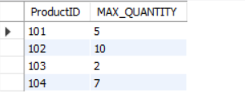

###----6) Write a query to calculate the average quantity of products sold per region.

**select Region,avg(quantity) as AVG_QUANTITY from sales group by Region;**

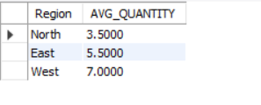

###----7) Find the product IDs that have generated a total sales amount of more than 1000.

**select ProductID from sales group by ProductID having SUM(Quantity*UnitPrice)>1000;**

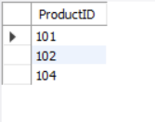

###----8) Write a query to get the total number of sales (rows) made for each customer.

**select CustomerID,sum(Quantity*UnitPrice) as Total_Sales from sales group by CustomerID;**

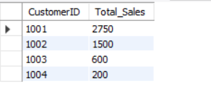

### 9. Find the products for which the average quantity sold is less than 5.

**select ProductID,avg(Quantity) as AVG_QUANTITY from sales where Quantity<5 group by ProductID;**

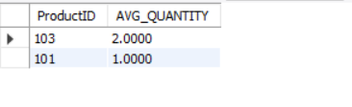

### 10. Write a query to find the sum of total sales for each customer in each region.

**select CustomerID,Region,sum(Quantity*UnitPrice) as Total_Sales from sales group by CustomerID,Region;**

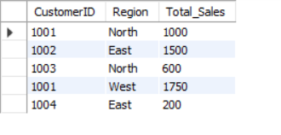

### 11. Write a query to calculate the total sales for each month.

**select Month(SaleDate) as Total_Month,sum(Quantity*UnitPrice) as Total_Sales from sales group by Month(SaleDate);**

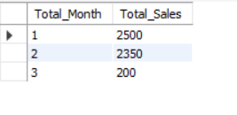

### 12. Find the regions where the average unit price is more than 200.

**select Region from sales group by Region,UnitPrice having avg(UnitPrice)>200;**

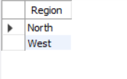

### 13. Write a query to get the minimum and maximum quantity sold per region.

**select Region,min(quantity) as Minimum_Quantity,max(Quantity) as Maximum_Quantity from sales group by Region;**

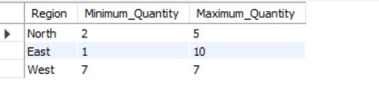

### 14. Find the customers who have made more than 2 purchases.

**select CustomerID from sales group by CustomerID having count(ProductID)>2;**

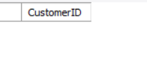

### 15. Write a query to find the total sales for each product and filter only those products where the total sales exceed 1500.

**select ProductID,sum(Quantity*UnitPrice) as Total_Sales from sales group by ProductID having sum(Quantity*UnitPrice)>1500;**

